**Quiz 2**

**Name: Zack Roder**

Graduation Rate: Kiplinger’s Personal Finance provides information on the best public and private college values. Some of the variables included in this issue are as follows. All are based on the most recent available data:

GRADRATE4: the percentage of students who earned a bachelor’s degree in four years.

ADMISRATE: admission rate expressed as a percentage

SFARATION: student to faculty ratio

AVGDEBT: average debt at graduation

This information is included in a file named COLLEGE4.

Use the graduation rate as the dependent variable and develop a regression equation.

1. Write the equation of the regression line in the standard form (4 points)

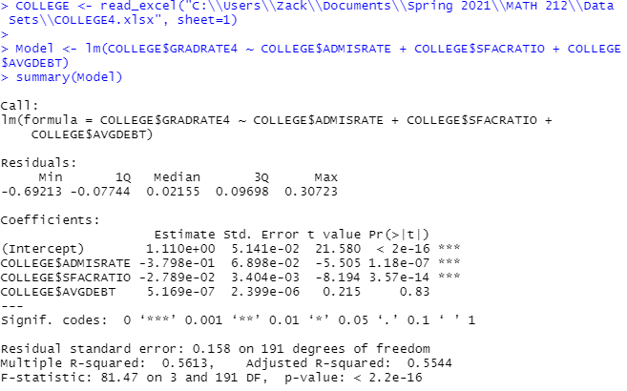

**GRADRATE4 = 1.11 – 0.3798*ADMISRATE – 0.02789*SFACRATIO + 0.0000005169*AVGDEBT**

2. Test the following hypothesis at 5% level of significance.

$$H_{0}:β_{\text{ADMISRATE}}=0$$

$$H_{a}:β_{\text{ADMISRATE}}≠0$$

Step 1: State the null and Alternative hypothesis using correct notation. (4 points)

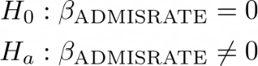

Step 2: Calculate the test statistic. (4 points)

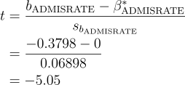

$$t=-5.505$$

Step 3: Calculate the p-value. Clearly draw a diagram and show complete work. (4 points)

**As we can clearly see in the plot, we expect the p-value to be close to 0.**

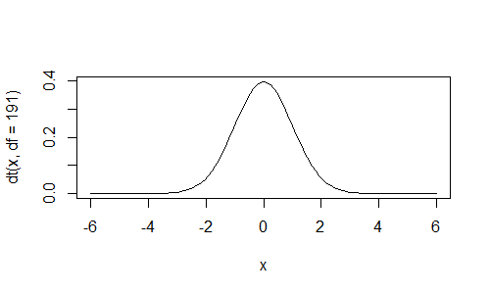



P-value = **1.18 * 10-7**

Step 4: Make a decision (4 points)

(a) Reject $H_{0}$

(b) Do not reject $H_{0}$

Step 5: Write the conclusion is context of the problem (4 points)

**Since our p-value is less than 0.05, we have reject $H_{0}$** . **We can conclude that there is sufficient evidence to conclude that ADMISRATE and GRADRATE are linearly related (even when the effect of SFACRATIO and AVGDEBT are taken into consideration).**

3. Construct a 95% confidence interval estimate of $β_{\text{ADMISRATE}}$ and interpret.

Step 1: Identify the following values (use R to compute these values)

$b_{\text{ADMISRATE}}=-0.3798$ (2 points)

$s_{b_{ADMINSTRATE}}=0.06898$ (2 points)

$n=195$ (2 points)

${ t}_{\frac{α}{2},n-K-1}=1.972$ (2 points)

Step 3: Substitute to find the upper bound and the lower bound of the confidence interval. Show work

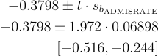

Lower bound: $-0.516$ (2 points)

Upper bound: $-0.244$ (2 points)

Step 4: Interpret the confidence interval in context of the problem (4 points):

**We’re 95% confident that every increase of ADMISRATE by 1 decreases GRADRATE by 0.244 to 0.516. For example, we’re 95% confident that a 10% (0.10) increase in ADMISRATE should decrease GRADRATE by some amount between 0.0244 (2.44%) and 0.0516 (5.16%).**